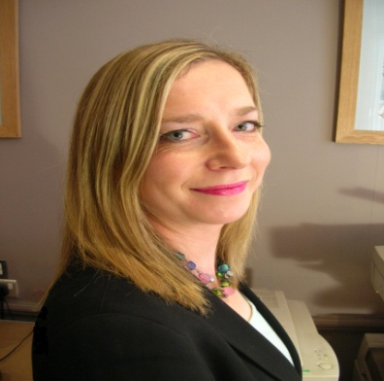
This event is
sponsored by:



Persuasive Presentations Seminar, London

Wednesday 20 October 2010
6.30pm
Nabarro LLP 84 Theobald's Road London WC1X 8RW



Making a positive impact!
Elspeth Mills Rendall, a barrister, now specialising in professional skills development, coaching and consultancy with a proven 18-year track record in training and development will give us key tips on presentation techniques including the art of persuasion, preparation and managing material, style for personality and tips for using visual aids and handling the audience.
Drinks and canapés will be served after the seminar with an opportunity to network with other guests.
To Apply: Please fill out and return the attached form together with your cheque (payable to "Women in Property") to: Michelle Kershaw, Nabarro LLP, Lacon House, 84 Theobald's Road, London, WC1X 8RW or via DX 77 London Chancery E: m.kershaw@nabarro.com T: 020 7524 6365.
------------------------------------------------------------------------------------------------------
Persuasive Presentations Members £25 Non-members £35
Name: …………………………………………………………………………………………………………..

Company: …………………………………………………………………………………………………………..

Contact Tel No: …………………………………………………………………………………………………………..

Email Address: …………………………………………………………………………………………………………..

Number of places required: ………Member………Non-Members

